St Mary’s RC Primary School and Nursery,
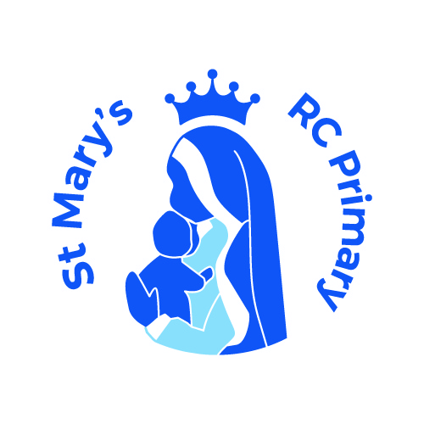

a Voluntary Academy

Tong Lane

Bacup

Lancashire

OL13 9LJ

Headteacher: Mrs C Mills
Telephone: 01706 873123
E-mail head@stmarys.romerocat.com
sbm@stmarys.romerocat.com
9th January 2023


Dear Parents and Families,

As part of our exciting EYFS curriculum, we are going to be learning about Chinese New Year. We will be having a Chinese New Year celebration day on Friday 20th January 2023. Children will be allowed to wear something red or yellow and take part in a range of activities to celebrate the year of the Rabbit. We will be tasting some delicious Chinese food and dancing with the Chinese Dragon. We are very much looking forward to learning about another culture.

Please fill out the permission slip below to allow your child to join in with the food tasting.

Yours Sincerely,

Miss Duffy and Mrs Burridge.

Name of Child:__________________________________________

Please delete as appropriate

I do/do not give permission for my child to taste Chinese food.

Signed: _____________________________________________________

