St Mary’s RC Primary School and Nursery
Tong Lane,
Bacup
OL13 9LJ
Tel: 01706873123
Email: admin@stmarys.romerocat.com
Website: www.stmarysbacup.org

Nursery Parent Information Booklet 2022-2023

Welcome to our Nursery

Here at St Mary’s we strive to;
- provide quality education for 3-4 year olds
- create a safe and caring learning environment offering a wide range of activities and learning opportunities which are educational, exciting and fun
- work in partnership with you as parents and carers to support your children on their learning journey

We will try to ensure your child’s stay with us is a happy, successful and enjoyable one.

Mission Statement
We welcome your child into our nursery where
‘We are happy living and learning in God’s friendship.’

Our Nursery staff

Mrs Burridge: EYFS Specialist HLTA

Mrs Plant: EYFS Specialist TA

Nursery sessions, funding and charges

Nursery Sessions
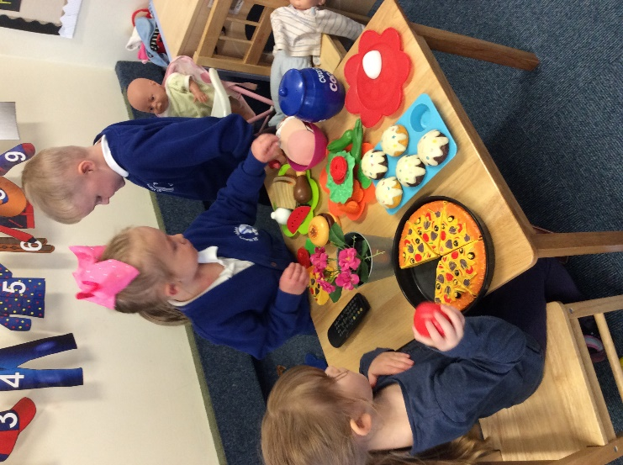
Morning session: 8.45am – 11.45am
Lunch time session: 11.45am - 12.15pm
Afternoon session: 12.15pm – 3.15pm
Full day: 8.45am – 3.15pm (staying for lunch - school meal or packed lunch)

All children receive 15 hours free childcare each week and fresh fruit for a snack each day.

If you would like more information on eligibility for the 30 hours, please see the Child Care Choices website.

Additional sessions:
In addition to your 15 hours free childcare, you are able to pay for further sessions:

Morning additional session (8.45am – 11.45am): £15
Afternoon additional session (12.15pm – 3.15pm): £15
Lunch time session (11.45am-12.15pm): £2.50

School Meal
Hot school meal – children’s choice: £2.30

Some children may be entitled to a free-school meal – please request a form if you think you may be eligible.

Other charges
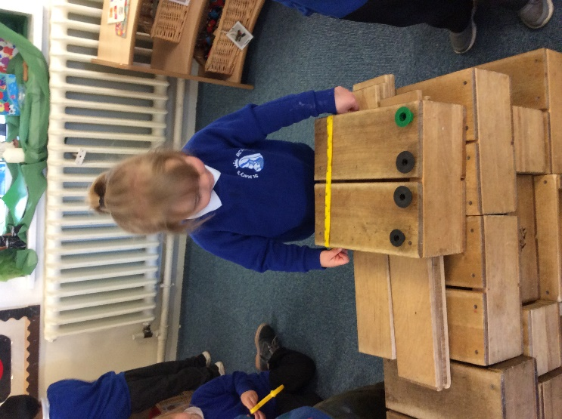
EYFS Pot
We kindly ask for a small donation of 50p per week towards the EYFS Pot. With this money the EYFS team plan and arrange a range of exciting activities in the classroom to enhance learning even further. This could be anything from sunflower seeds, rice, spaghetti, soap flakes or even ingredients to do some baking.

Late charge
If your child is picked up 5 minutes or later a £5 late fee will be charged. If it is the first occasion of late collection and the parent/carer has notified the school that they are held up then no charge will be made for the supervision of the child. Late collection is from the main office.

The Early Years Foundation Stage Curriculum
The Early Years Foundation Stage (EYFS) starts at birth and continues until the end of the Reception year. There are four themes to the EYFS:

- A unique child- every child is a unique child who is constantly learning and can be resilient, capable, confident and self-assured.
- Positive relationships- children learn to be strong and independent through positive relationships.
- Enabling environments – Children learn and develop well in enabling environments, in which their experiences respond to their individual needs and there is a strong partnership between practitioners and parents and carers.
- Learning and development - There are seven areas of learning and development. All areas of learning and development are important and interconnected. Each area of learning and development is implemented through planned, purposeful play.

The Prime Areas
Personal, social and emotional development | - Self-regulation  - Managing self  - Building relationships
Communication and language | - Listening, attention and Understanding  - Speaking
Physical development | - Gross Motor skills  - Fine motor skills
The Specific Areas
Literacy | - Comprehension  - Word reading  - Writing
Maths | - Number  - Numerical patterns
Understanding of the world | - Past and Present  - People, Culture and Communities  - The Natural World
Expressive arts and design | - Creating with materials  - Being imaginative and expressive

At our nursery, activities are planned around a long-term topic plan and also to reflect children’s interests and individual circumstances in order to provide each child with a challenging and enjoyable experience. A copy of what your child will be learning will be on our half-termly curriculum map which parents can find on the school website, along with other information.

Outdoor Play

Being outdoors has a positive impact on children’s sense of wellbeing and helps all aspects of children’s development.

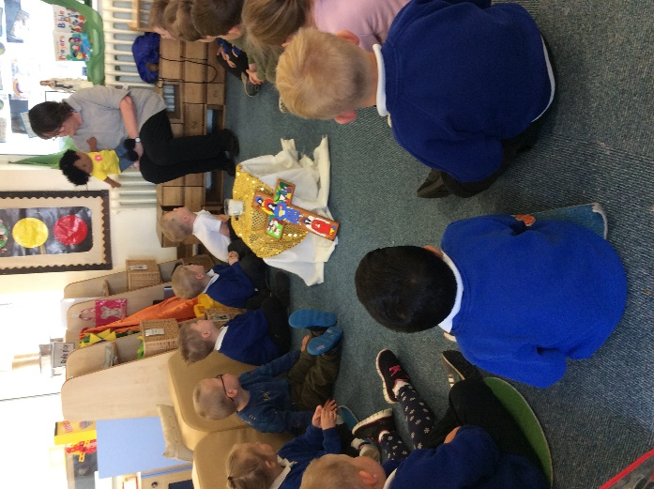
We believe that outdoor play is an integral part of early learning. The children are allowed free access to the outdoors for a large amount of time during each session. Wellies and waterproof ponchos are provided for the children. Please ensure your child is dressed suitably for the weather

Admission arrangements
Children may attend the nursery after they turn 3 years old. Parents and carers can register their child at any time prior to their third birthday and are welcome to visit the nursery and meet the staff for a tour.
If the nursery has more applications for admission than it has places available the following criteria will be used to allocate places:
- Baptised Catholic Looked After Children and Baptised Catholic previously Looked After Children.
- Baptised Catholic children who have a sibling in the school at the time of admission.
- Baptised Catholic children resident in the former parish of St. Mary’s Bacup
- Other Baptised Catholic Children.
- Looked After Children and previously Looked After Children.
- Other children who have a sibling in the school at the time of admission.
- All remaining applicants

Arrival and collection arrangements
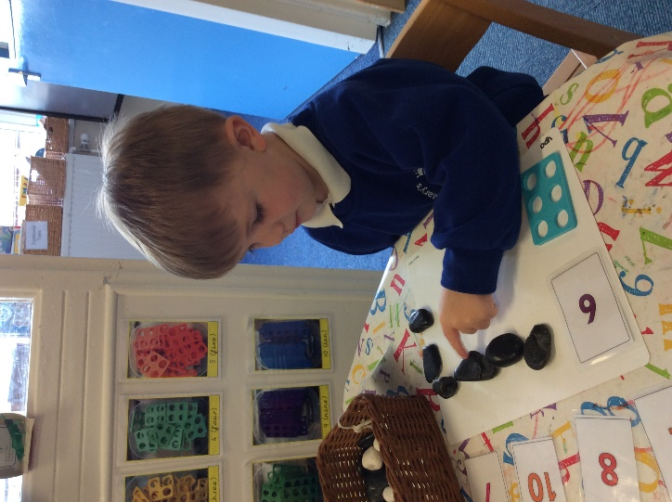
Children and parents may wait in the cloakroom until the nursery door is opened at the beginning of each session 8.45am and 12.15pm.

At the end of the session please wait in the cloakroom where your child will be brought to you. The door from the cloakroom to the nursery is bolted at all times for your child’s safety. Please note, parents must not enter into the nursery classroom unless a meeting has been arranged in advance.

Safe collections
Please ensure your child is collected on time and that you inform us if someone else will be collecting your child if they are not on the safe collection list – they must give the password in order to collect your child. Please note children can only be handed over to adults over 16 years of age.

Non Collection of Child Procedure
In the unlikely event that a child is not collected from nursery the following procedure will be followed:
If a child is not collected at the end of the session the parent or carer will be contacted by telephone at home or at work. If you cannot be contacted the emergency contact numbers on your child’s admission form will be tried. If you’re more than 5 minutes late to collect, you will need to collect your child from the main office and you will incur a late fee of £5.

Please note, if no one can be reached after 60 minutes the local police will be informed of the situation and the Referral Team of the local Children’s Social Care department will be contacted.

Codes of behaviour
Our nursery rules are ‘Kind hands, Kind feet and Kind words.'

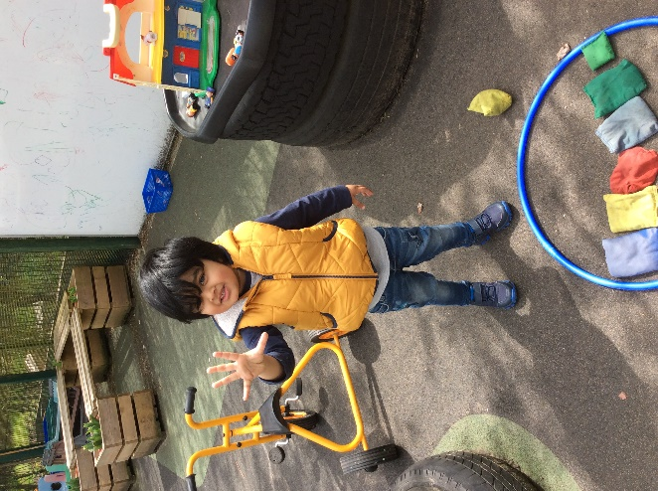
We expect all children to be well behaved as this creates a calm and happy atmosphere in the nursery. This means being polite, caring towards others and respecting property and equipment. Children are encouraged to walk inside at all times. In nursery, we have a traffic light displayed with photographs of each child displayed on green each day. Children will be given reminders if they are not making the right choices and if they continue, they will move to yellow and then to red. If your child has moved to red, they will have a time out from the activity and we will inform you at the end of the session if they have moved to red more than once and talk through what has occurred. For exceptional behaviour and good learning choices, a star of the day will be chosen and this child’s photo will move up to the gold star. We use stickers on a daily basis to praise good choices.

Settling in procedure
Children and parents are invited to visit the nursery together before they are due to start in order to get to know the staff and the nursery environment for a settling in session/meeting. On your child’s first day you may leave your child for up to 1-2 hours to see how they settle, this time will be increased each day if they settle well. The staff will talk to you about how your child has settled each day. You may telephone the nursery to enquire how your child has settled if you are worried. We will always contact you if your child is in distress or cannot be settled.

Nursery Contractual Agreement
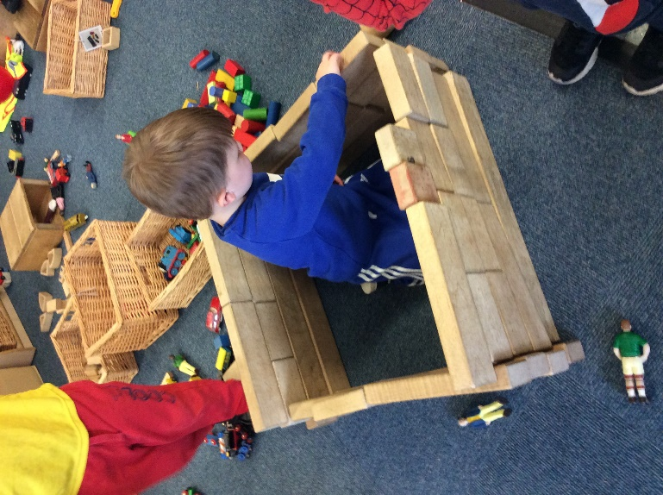
During the initial settling in session/meeting, parents will be invited to meet with the class teacher whilst their child has a settling in session. During this meeting, parents are given the chance to ask any questions they may have and gain more of an insight into life at St Mary’s Nursery. Parents will agree session hours with the class teacher and complete necessary paperwork, agreeing to the terms and conditions of the contract.

Comfort Objects
A favourite toy or object may be brought to nursery with your child during the settling in period if you think this will help your child. Please do not bring toys to nursery after this time as they can easily get lost or broken.

Nappy Changing/toilet training
If your child is not yet toilet trained the staff will work with you to achieve this. An intimate care plan will need to be completed.

Please provide a bag with nappies/pull ups, wipes and a change of clothes. This bag can be left on your child’s coat hook. Please ask to see the nappy changing policy or contact your health visitor for more advice.

When your child is showing signs they are ready to be toilet-trained, we will first discuss this with parents and then work closely together to help the child move on with this stage.

Nursery routine / key person
It is important that young children have set routines. Each child has a key person who will help them get to know the nursery routine and ensure that they settle quickly. The key person will build up a strong relationship with you and your child and help you in meeting your child’s needs at home. If you would like to see who your child’s key person is, please see the nursery notice board.

Uniform
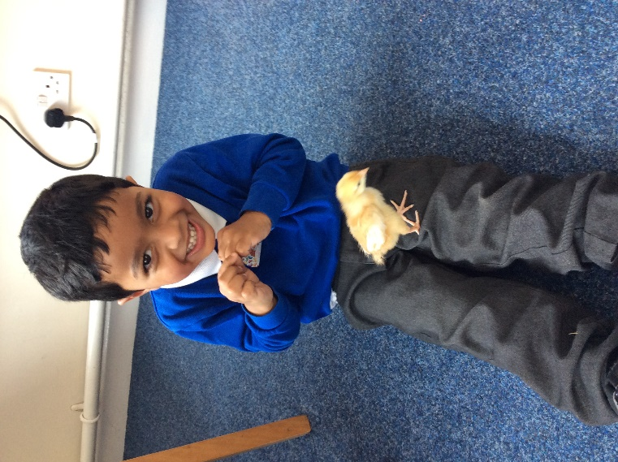
St Mary’s do have a school uniform however this is optional to wear in nursery. Children must come appropriately dressed for the weather. All long hair needs to be tied back and children must not come into nursery wearing ear rings. If your child has their pierced during term time, they must wear plasters over their ears for 6 weeks and then after that, they must be taken out each day.

Spare change of clothes
Your child will need a bag with a spare change of clothes in every day. Even if your child is toilet-trained, sometimes accidents can occur and they may need to be changed. On the odd occasion, they may get wet or muddy from outside and will need to be changed. We do have nursery clothes in emergencies which need to be washed and returned as soon as possible. Any donations of old/spare clothes are greatly appreciated.

Smile4 Life
The nursery has smile4life accreditation which means that only healthy sugar free snacks and drinks are provided. Mrs Burridge is the named Oral Health Champions and will provide you with any information or advice. The children are able to select milk or water and a piece of fruit for a snack each session. Water is available at all times.

We celebrate the children’s birthdays with our special celebration box which includes candles to blow out, a birthday card, a badge and a birthday sheet to fill in at home with your child.

Please do not send sweets or cakes into nursery.

Absence
If your child is not attending Nursery, please make contact with the Nursery to inform us of the absence and the reason. Parents agree that a child who is kept off ill (with any contagious illness) will be kept at home for the well-being of staff and other children in our care. Should a child become ill whilst at Nursery, Nursery will inform parents and parents agree to collect their child immediately. Children cannot be readmitted to Nursery until they have become symptom free and in some cases, a doctor’s note may be necessary.

Illness action to be taken

Illness | Action to be taken
Vomiting | Exclusion for 48 hours after last occurrence
Diarrhoea | Exclusion for 48 hours after last occurrence
Chicken Pox | 5 days from onset of rash
German Measles | 5 days from onset of rash
Mumps | 5 days from onset of swelling
Conjunctivitis | Follow doctor’s advice
Measles | 5 days from onset of rash
Impetigo | Exclusion until lesions are crusted or healed

If your child needs essential medication, e.g. an inhaler or epipen, please leave a spare one at the nursery, a care plan will need to be completed. If your child needs medication prescribed by a doctor, you must complete an authorisation form before we can administer any medicines to your child. No other medicines will be administered. Please note, it must be in the original packaging with the label clearly displayed.

Working closely with Reception class
Our EYFS at St Mary’s is made up of a Nursery class and a Reception class. Both classes follow the same topics and throughout the year will join together for various projects, play sessions, visitors in school and trips out of school.

Your Child’s Progress
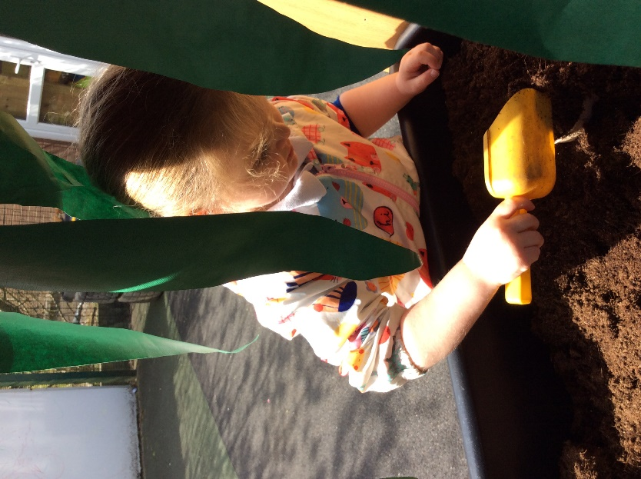
During your child’s time in EYFS at St Mary’s, they will have a special Learning Journey book which will document your child’s achievement as the year progresses through photographs, observations and their creations. Learning Journeys are used to monitor the skills that your child is developing and records what your child has said or accomplished during their play and exploration. This enables staff to plan effectively in order to meet children’s individual learning needs and next steps/targets, showing their progress along the way. It also serves as a reminder of the wonderful experiences children have and highlights discoveries that they make.

Throughout the year there will be opportunities for you to discuss your child’s progress with the staff. You will receive a termly report on your child’s progress and will be invited to parents evenings twice a year. Our school has an open-door policy and parents are welcome to talk to teachers at the start and end of the school day. We believe that children progress well when parents and staff work together and share information. If you feel that your chat with teachers may take longer than a minute or so, please book a meeting with either the main school office or your class teacher.

Parental involvement

There are many ways in which you can help your child and be involved with the nursery. Here are just a few examples:

- Reading a bedtime story each night encourages a love of books
- Saying or singing nursery rhymes or songs with your child develops a sense of rhyme and rhythm which is an important part of learning to read
- Talking together improves vocabulary and understanding
- Playing games together helps with turn taking and sharing

To support you with your child’s learning and development we send home song sheets and learning challenges on a regular basis. We also send home a ‘Busy Bag’ which will have a book alongside some resources and suggested fun activities you can complete with your child.

Nursery library
Each week you may choose a book to share with your child from our lending library and an activity sheet with a song or rhyme to sing together and/or a picture to colour or a game to play. Please remember to return the books after you have read it before choosing a new one.

You are welcome to look at your own child’s learning journey whenever you wish.

We hope your child will have an enjoyable time with us and we look forward to meeting and getting to know you and your child.

