St Mary’s RC Primary School and Nursery,
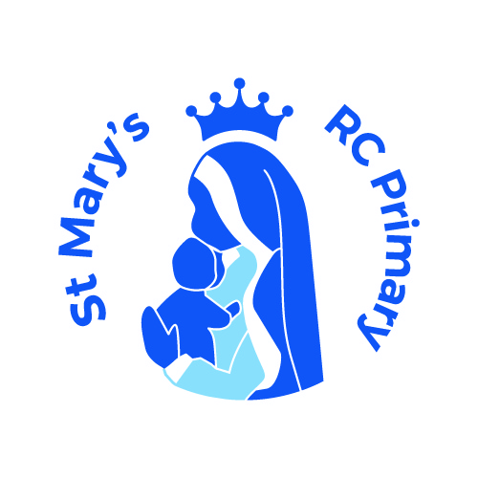

a Voluntary Academy

Tong Lane

Bacup

Lancashire

OL13 9LJ

Headteacher: Mrs C Mills
Telephone: 01706 873123
E-mail head@stmarys.romerocat.com
sbm@stmarys.romerocat.com
9th September 2022

Introduction & Curriculum Newsletter for Autumn 1 (the first half term)

Dear Parents and Families,

We have had a lovely start to the term and everyone has settled back in nicely to Nursery and Reception. The children have had lots of fun getting to know their new classroom and teachers.

Here at St Mary’s, the Early Years Foundation Stage (EYFS) is made up of a Nursery class and a Reception class. Our EYFS staff work together as a team to provide quality provision which enables each child to develop their talents, personalities and abilities in a safe and stimulating environment.

The staff in our Nursery class are: Mrs Burridge (HLTA) and Mrs Plant (TA)


The staff in our Reception class are: Miss Duffy (Class teacher and EYFS Lead) and Ms Rowley (TA)


Both classes will be learning the same topics this year and we really look forward to the exciting learning which will take place. Our new topic this half term is ‘Rainforests’ and as part of this topic, children will gain an understanding of Rainforests and the different types of animals who live there. We will also have a very exciting visit from Zoo Lab who will be bringing in lots of different animals for us to look at and touch!
We will be continuing with our behaviour traffic light system which is in line with our whole school behaviour policy. Children will always begin the day on green and will have the opportunity to move up to gold for outstanding behaviour and attitudes. The colours are based around the traffic light system and we will move children to amber and then red to show your child if they have made the wrong choices. If your child has moved to red, we will inform you at the end of the session/day and talk through what has occurred.
We will also be sending home WOW Moment slips which allows you to let us know about anything your child does at home which impresses or surprises you! We really do enjoy reading about what your children have been getting up to so please send them in to us.
Nursery and Reception Class information:
This Autumn term our topics are going to be:
· Rainforests and Into the Woods/Christmas
. RE - Welcome
Our PE days are going to be:
· Reception - Wednesdays and Thursdays.
. Nursery -.Wednesdays
Homework is going to be:
· Nursery - Lending library, occasional song sheets/nursery rhymes, Busy Bag swapped every week
.Reception - reading book, phonics/words, a sheet linked to fine motor skills/phonics/maths

Please ensure your child’s name is in all items of clothing.
Finally, we are very excited about the year ahead and very much look forward to working closely with you as your child progresses through EYFS at St Mary’s. If you are unsure of anything at any time or wish to see us about anything concerning your child please do not hesitate to come and speak to us. Thank you for your continued support.

If you have any questions or would like to arrange an appointment to see me or Mrs Burridge, please contact us via email at eduffy@stmarys.romerocat.com/kburridge@stmarys.romerocat.com or the school office on sbm@stmarys.romerocat.com.

Many Thanks,
Miss Duffy and the EYFS team.

