St Mary’s RC Primary School and Nursery,
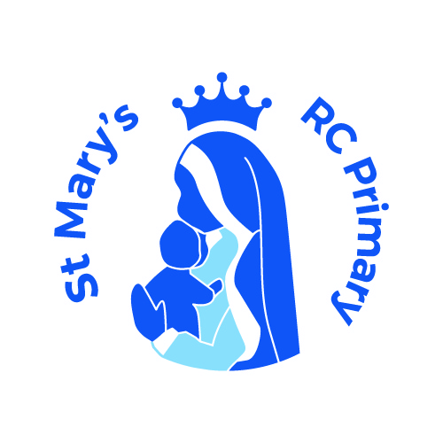

a Voluntary Academy

Tong Lane

Bacup

Lancashire

OL13 9LJ

Headteacher: Mrs C Mills
Telephone: 01706 873123
E-mail head@stmarys.romerocat.com
sbm@stmarys.romerocat.com

Friday 23rd September 2022
Dear Parents and Families,

Now that your child has settled in well to the Reception class, we will be introducing ‘Key Worker’ groups. Your child will be allocated to a key worker, this will either be myself or Ms Rowley. A Key worker’s role is to support your child in any way they can, building firm foundations and supporting progress. As outlined in the EYFS Statutory Framework, ‘Each child must be assigned a key person. Their role is to help ensure that every child's care is tailored to meet their individual needs, to help the child become familiar with the setting, offer a settled relationship for the child and build a relationship with parents.'

It is important to note that both Ms Rowley and I will develop a relationship with all pupils. This will ensure all children are included and that each individual pupil’s needs are met and accommodated for. Although each child will have a named key person, it will be my responsibility to plan and teach the main class activities and I will have overall supervision of the observations and next steps of all of the children to track their progress.

If you have any questions at all, please do not hesitate to contact me.

Yours Sincerely,

Miss Duffy.

Name of child:

Key Worker:

